**Data and Methods**

## **Data Used**

### ***General Social Survey***

The dataset used in this analysis is the General Social Survey, a nationally representative survey of the attitudes and behaviors of adults (18 and over) in the United States, which was pulled from the official National Opinion Research Center (NORC) website. The survey is taken by NORC every one to two years, with cumulative cross-sectional datasets available from the year 1972 to 2021[1]. The specific data employed will be the 2016-2020 Panel (Davern et al., 2022) updated in April 2022, which sampled 6,200 housing units in 2016, with a final tally of 2,867 completed individual interviews, and 5,200 housing units in 2018, with a final tally of 2,348 respondent individuals. The 2020 respondents were then reinterviewed from a full sample of the 2018 wave, and a random subsample of 2,146 (74.85%) from the 2016 wave. The total number of included observations was 5,215, however, accounting for attrition and respondent non-answers[2], the total number of identifiable observations was 1,823 (34.95%). For the purpose of tracking the same respondents across waves, only those who participated in the 2018 survey were considered, reducing the final manipulable observation number to 1,014 respondents.

### ***American National Elections Survey***

All respondents who completed the 2020 wave of the GSS, and were U.S. citizens at the time of study, were then offered a second survey administered by the American National Elections Study (ANES). The ANES is one of the oldest continuous series of survey data of electoral behavior and general attitudes in the United States and it is used here to track social participation determinants as mediators between loneliness, cohesion, health and happiness. By tracking political involvement within the United States, the variables extracted from the ANES will give us a clearer view of the role of community participation within patterns of online and offline communication. In fact, the surveys are taken before and after presidential and national congressional elections by both the Institute of Social Research at the University of Michigan and the Institute for Research in the Social Sciences at Stanford University; latest efforts have included experts from Duke University and the University of Texas at Austin (Howell, 2022). Regarding sample size, about two-thirds of the GSS respondents completed the ANES survey, with a final observation count of 635 once the data is filtered for only those present in the 2018 sample. The ANES will also act as an extension to complete otherwise incomplete data, due to the GSS’s high missing observations count.

*Table 1: Individual Respondent Characteristics by Year (cont.)*

|  |  |  |  |  |  |  |
| --- | --- | --- | --- | --- | --- | --- |
|  | *year* | | | | |  |
|  | *2018* | | *2020* | | *Total* | *Sample size* |
|  | % | SE | % | SE | % |  |
| *Age in Categories* |  |  |  |  |  |  |
| 18-25 | 63.2 | (1.728) | 36.8 | (1.728) | 100.0 | 154 |
| 26-45 | 51.6 | (0.810) | 48.4 | (0.810) | 100.0 | 717 |
| 46-64 | 53.4 | (0.895) | 46.6 | (0.895) | 100.0 | 617 |
| 65+ | 49.3 | (1.015) | 50.7 | (1.015) | 100.0 | 537 |
| Total | 52.9 | (0.497) | 47.1 | (0.497) | 100.0 | 2,025 |
| *Region of Interview* |  |  |  |  |  |  |
| North-East | 52.4 | (0.961) | 47.6 | (0.961) | 100.0 | 285 |
| Midwest | 54.9 | (0.978) | 45.1 | (0.978) | 100.0 | 445 |
| South | 50.7 | (0.995) | 49.3 | (0.995) | 100.0 | 801 |
| West | 55.2 | (1.013) | 44.8 | (1.013) | 100.0 | 497 |
| Total | 53.0 | (0.472) | 47.0 | (0.472) | 100.0 | 2,028 |
| *Respondent census occupation code (23 categories)* |  |  |  |  |  |  |
| Management | 54.9 | (2.788) | 45.1 | (2.788) | 100.0 | 203 |
| Business and Financial Operations | 50.6 | (3.671) | 49.4 | (3.671) | 100.0 | 97 |
| Computer and Mathematical | 43.6 | (5.744) | 56.4 | (5.744) | 100.0 | 59 |
| Architecture and Engineering | 54.5 | (5.983) | 45.5 | (5.983) | 100.0 | 33 |
| Life, Physical, and Social Science | 48.8 | (7.550) | 51.2 | (7.550) | 100.0 | 26 |
| Community and Social Service | 51.9 | (6.181) | 48.1 | (6.181) | 100.0 | 39 |
| Legal | 66.0 | (5.540) | 34.0 | (5.540) | 100.0 | 25 |
| Education, Training, and Library | 53.4 | (3.183) | 46.6 | (3.183) | 100.0 | 149 |
| Arts, Design, Entertainment, Sports, and Media | 51.6 | (6.219) | 48.4 | (6.219) | 100.0 | 56 |
| Healthcare Practitioners and Technical | 52.0 | (3.490) | 48.0 | (3.490) | 100.0 | 143 |
| Healthcare Support | 55.3 | (4.617) | 44.7 | (4.617) | 100.0 | 62 |
| Protective Service | 49.1 | (6.593) | 50.9 | (6.593) | 100.0 | 36 |
| Food Preparation and Serving Related | 61.1 | (4.120) | 38.9 | (4.120) | 100.0 | 95 |
| Building and Grounds Cleaning and Maintenance | 48.2 | (5.706) | 51.8 | (5.706) | 100.0 | 75 |
| Personal Care and Service | 47.3 | (5.639) | 52.7 | (5.639) | 100.0 | 64 |
| Sales and Related | 52.6 | (3.305) | 47.4 | (3.305) | 100.0 | 179 |
| Office and Administrative Support | 49.7 | (2.713) | 50.3 | (2.713) | 100.0 | 223 |
| Farming, Fishing, and Forestry | 47.1 | (16.231) | 52.9 | (16.231) | 100.0 | 11 |
| Construction and Extraction | 52.9 | (4.614) | 47.1 | (4.614) | 100.0 | 80 |
| Installation, Maintenance, and Repair | 50.9 | (7.086) | 49.1 | (7.086) | 100.0 | 50 |
| Production | 52.3 | (4.165) | 47.7 | (4.165) | 100.0 | 117 |
| Transportation and Material Moving | 57.5 | (3.199) | 42.5 | (3.199) | 100.0 | 118 |
| Military Specific | 100.0 | (0.000) | 0.0 | (0.000) | 100.0 | 10 |
| Total | 52.9 | (0.510) | 47.1 | (0.510) | 100.0 | 1,950 |
| Source: 03_GSS_ANES_merge | | | | | | |

**Model Specification and Testing**

The effect of loneliness on our variables of interest was measured at a high to low categorical scale, expecting increased effects on the extreme ends of the distribution, while the majority near the mean either does not experience significant correlations or sees relationships different from the tails. As such, the model used was an Ordered Logit Fixed Effects, with the dependent variable being coded as to distinguish the three distinct categories (High, Medium, Low).

### ***Fixed Effects vs. Random Effects***

The choice of Fixed Effects over Random Effects arises from the presence of similar individuals across waves, which allows us to account for time-invariant observed characteristics without the need for further controls. In the case of the Fixed Effects, the individual heterogeneity is included in the intercept and allowed to be correlated with other regressors, while the Random Effects model places the assumption that the individual effect is not correlated with the regressors, estimating the error variance (Park, 2011).

*Happiness Equation*: ${Happy}_{it}=\left(α+u_{i}\right)+{Lonely}_{it}^{'}β+{Intcnct }_{it}β+ {Control}_{it}β+ v_{it}$

*Health Equation*: ${Health}_{it}=\left(α+u_{i}\right)+{Lonely}_{it}^{'}β+{Intcnct }_{it}β+ {Control}_{it}β+ v_{it}$

*Cohesion Equation: ${Cohesion}_{it}=\left(α+u_{i}\right)+{Lonely}_{it}^{'}β+{Intcnct }_{it}β+ {Control}_{it}β+ v_{it}$*

$$v_{it} \sim IID(0, σ_{v}^{2})$$

Given that we assume that the observations are unique from each other, and we want to draw conclusions from the differences among each individual, the Within-Effect Fixed Effects model is more appropriate, especially since we have a limited number of respondents and time periods to analyze (Yang & Land, 2008). Further, the limitation placed on the use of only two years of data could make it so that using a First Difference (FD) model would be better: $y_{it}- y_{it-1}=\left(α_{t}- α_{t-1}\right)+β\left(x_{it}- x_{it-1}\right)+(ε_{i}- ε_{it-1})$. However, FD assumes that the idiosyncratic error term is serially uncorrelated with each period, which can be problematic with vulnerable population analysis during the COVID-19 period (Especially seniors; Fawcett & Karastoyanova, 2022).

While still maintaining unique categorization, and the difference between extremes and middle values, estimation of the Ordered Logit model can be performed through a variety of methods that employ the reduction of the model to a binary estimation without loss of information: Chamberlain’s CML estimator, Das and van Soest’s estimator, the Ferrer-i-Carbonell and Frijters estimator, and The “Blow Up and Cluster” (BUC; Baetschmann et al., 2015). The latter seems to be more efficient in smaller sample contexts (Riedl & Geishecker, 2014), and a community contribution STATA command package described by Baetschmann, Ballantyne, Staub and Winkelman (2020) – *feologit –* allows for its easy use within the statistical program, with the option of a hybrid BUC-τ if we assume constant thresholds across individuals.

### ***Health***

Self-Perceived *health* was originally measured through a 4-point scale answering the following: “Would you say your own health, in general, is excellent, good, fair, or poor?” The scale adopted the Excellent, Good, Fair, Poor distinction, but the “Poor” category was collapsed into the “Fair” category due to the limited number of observations. A Shapiro-Wilk test on the non-collapsed variables revealed that the distribution was indeed marginally non-normal (z = 1.580, p = 0.05701), although the 2018 wave showed the opposite (z = 2.123, p = 0.01690).

### ***Happiness***

Self-Perceived *happiness* was measured through a 3-point scale answering the following: “Taken all together, how would you say things are these days--would you say that you are very happy, pretty happy, or not too happy?” The scale adopted the Very Happy, Pretty Happy, and Not Too Happy distinction, which was not modified for easier categorization.

### ***Social Cohesion***

Measures for social cohesion were separated into three distinct dummies with three distinct set of responses: *trust* (“Generally speaking, would you say that most people can be trusted or that you can't be too careful when dealing with others?”), *fair* (“Do you think most people would try to take advantage of you if they got a chance, or would they try to be fair?“), and *helpful* (Would you say that most of the time people try to be helpful, or that they are mostly just looking out for themselves?”). Certain authors like Mewes, Fairbrother, Giordano, Wu, & Wilkes (2021) took the mean of the three variables to obtain a generalized dependent scale going from 0 to 1, with 0 indicating negative connotations of trust, while numbers closer to 1 pointed at higher trust and social cohesion. On the other hand, others like Glanville, Andersson, and Paxton (2013) created a composite index of latent generalized trust, which was based on a previous analysis by Paxton (1999) confirming the stability of these parameters when aggregated together[3].

In this paper, the parameters were standardized into a 0 and 1 dichotomy, collapsing the “Depends” answer common of all three into the 0 level (Carl & Billari, 2014), and a scale was created measuring from 0 (“Not Fair, Not Helpful, Not Trustworthy”) to 4 (Fair, Helpful, Trustworthy. The category merging was justified by the low cell value of the category, and the perceived negative connotation of doubt when inquired on the reliability of other people. On the other hand, the scale permits an easier indication of degrees of social cohesion, while treating all components with similar weight of importance.

## **Independent Variables**

The calculation of the independent variables will vary across years, as not all elements of the 2018 questionnaire were included in the 2020 questionnaire. However, the wording of differentiated variables was similar across the two waves, and the ANES addendum helps complement the missing aspects of certain omitted variables. To this latter point, certain variables were combined to complete the missing information.

### ***Loneliness***

Measures of loneliness were identified by the *lonely3* parameter (“How often in the past 4 weeks have you felt that you are left out?”) in 2018, and by the *lonely1* and *lonely2* parameters (“How often in the past 4 weeks have you felt that you lack companionship?”; “How often in the past 4 weeks have you felt that you are isolated from others?”) in 2020. While *lonely3* seems to directly capture the aspect of emotional loneliness we want to express (Prohaska et al. 2020), *lonely1* and *lonely2* seem to distinguish emotional loneliness with physical loneliness, the latter as a consequence of concrete restrictions of interaction (Holt-Lunstad & Steptoe, 2022). The variable *conwkday* in 2018 measures the number of people a respondent contacts in a typical weekday (“Please indicate about how many people do you have contact with on a typical weekday irrespective of whether you know them or not. Include anyone you chat with, talk to, or text, either face-to-face, by phone, internet or any other communication device.”), which was used as a way to pair the *lonely3* variable in 2018 to mirror the physical-emotional dichotomy available in 2020. As such we would obtain two distinguished measures of both emotional and physical loneliness that would determine which is more important in the variation of health, happiness, and trust (Lee & Lee, 2010; Vacchiano & Bolano, 2021). Previous literature predicts that the former will have a lesser, though still negative, effect on the three if we take into account a person’s preferred method of communication (Digital or Physical; Steafnone et al., 2011).

*Table 2: Initial Survey Statistics With Standard Errors*

|  |  |  |  |  |  |  |  |  |
| --- | --- | --- | --- | --- | --- | --- | --- | --- |
|  | *Loneliness Scale (Physical and Emotional)* | | | | | | |  |
|  | *Rarely* | | *Sometimes* | | *Often* | | *Total* | *Sample size* |
|  | % | SE | % | SE | % | SE | % |  |
| *General Happiness* |  |  |  |  |  |  |  |  |
| very happy | 70.0 | (3.174) | 28.4 | (3.099) | 1.5 | (0.724) | 100.0 | 351 |
| pretty happy | 55.3 | (2.103) | 38.2 | (2.013) | 6.5 | (0.989) | 100.0 | 768 |
| not too happy | 38.4 | (3.442) | 40.3 | (3.830) | 21.3 | (2.293) | 100.0 | 370 |
| Total | 54.9 | (1.511) | 36.3 | (1.409) | 8.8 | (0.855) | 100.0 | 1,489 |
| Pearson: Uncorrected chi2(4)= 130.391 | | | | | | | | |
| Design-based F(3.66, 281.48)= 20.675 | | | | | | | | |
| P-value= 0.000 | | | | | | | | |
| *Perceived Health* |  |  |  |  |  |  |  |  |
| Excellent | 65.8 | (4.284) | 28.4 | (3.900) | 5.8 | (2.329) | 100.0 | 201 |
| Acceptable | 55.2 | (2.191) | 36.8 | (2.446) | 8.1 | (1.358) | 100.0 | 514 |
| Poor | 50.0 | (3.553) | 35.0 | (3.567) | 15.0 | (2.784) | 100.0 | 277 |
| Total | 56.1 | (1.880) | 34.5 | (1.783) | 9.4 | (1.071) | 100.0 | 992 |
| Pearson: Uncorrected chi2(4)= 21.500 | | | | | | | | |
| Design-based F(3.69, 265.61)= 3.331 | | | | | | | | |
| P-value= 0.013 | | | | | | | | |
| *Cohesion Index* |  |  |  |  |  |  |  |  |
| Not Fair, Not Helpful, Not Trustworthy | 47.2 | (3.120) | 39.9 | (3.274) | 12.9 | (2.040) | 100.0 | 330 |
| At least two No | 55.7 | (3.983) | 39.1 | (3.942) | 5.2 | (1.365) | 100.0 | 244 |
| At least two Yes | 57.7 | (3.291) | 35.3 | (3.499) | 6.9 | (1.508) | 100.0 | 297 |
| Fair, Helpful, and Trustworthy | 56.3 | (2.872) | 39.1 | (3.247) | 4.6 | (1.290) | 100.0 | 266 |
| Total | 53.9 | (1.781) | 38.3 | (1.785) | 7.7 | (0.842) | 100.0 | 1,137 |
| Pearson: Uncorrected chi2(6)= 21.982 | | | | | | | | |
| Design-based F(5.32, 393.53)= 3.061 | | | | | | | | |
| P-value= 0.009 | | | | | | | | |
| Source: 03_GSS_ANES_merge | | | | | | | | |

*Table 3: Main Variables*

|  |  |  |  |  |  |  |
| --- | --- | --- | --- | --- | --- | --- |
|  | *year* | | | | |  |
|  | *2018* | | *2020* | | *Total* | *Sample size* |
|  | % | SE | % | SE | % |  |
| *General Happiness* |  |  |  |  |  |  |
| very happy | 63.6 | (1.786) | 36.4 | (1.786) | 100.0 | 508 |
| pretty happy | 54.9 | (1.286) | 45.1 | (1.286) | 100.0 | 1,079 |
| not too happy | 34.4 | (2.521) | 65.6 | (2.521) | 100.0 | 437 |
| Total | 53.1 | (0.470) | 46.9 | (0.470) | 100.0 | 2,024 |
| *Perceived Health* |  |  |  |  |  |  |
| Excellent | 58.6 | (2.391) | 41.4 | (2.391) | 100.0 | 292 |
| Acceptable | 53.2 | (1.382) | 46.8 | (1.382) | 100.0 | 698 |
| Poor | 47.0 | (2.897) | 53.0 | (2.897) | 100.0 | 364 |
| Total | 52.9 | (0.615) | 47.1 | (0.615) | 100.0 | 1,354 |
| *Cohesion Index* |  |  |  |  |  |  |
| Not Fair, Not Helpful, Not Trustworthy | 52.8 | (2.109) | 47.2 | (2.109) | 100.0 | 380 |
| At least two No | 58.9 | (2.962) | 41.1 | (2.962) | 100.0 | 295 |
| At least two Yes | 50.9 | (2.495) | 49.1 | (2.495) | 100.0 | 345 |
| Fair, Helpful, and Trustworthy | 51.4 | (2.459) | 48.6 | (2.459) | 100.0 | 303 |
| Total | 53.4 | (0.500) | 46.6 | (0.500) | 100.0 | 1,323 |
| *Loneliness Scale (Physical and Emotional)* |  |  |  |  |  |  |
| Rarely | 36.6 | (1.509) | 63.4 | (1.509) | 100.0 | 807 |
| Sometimes | 45.1 | (1.869) | 54.9 | (1.869) | 100.0 | 544 |
| Often | 11.5 | (3.052) | 88.5 | (3.052) | 100.0 | 141 |
| Total | 37.5 | (0.921) | 62.5 | (0.921) | 100.0 | 1,492 |
| Source: 03_GSS_ANES_merge | | | | | | |

### ***Communication Methods***

Measures of communication were determined by the variables *conf2f* (“About how many of these people do you see face-to-face on a typical weekday?”) and *intcntct* (“Think now of your contact with all of your family members and close friends. How much of it is through text messages, mobile phones, or other communication devices that use the internet?), which consider respectively the number of physical interactions and digital interactions a person faces. However, both variables were exclusive to the 2018 wave, and their wording doesn’t concurrently specify the time frame by which the questioned interactions take place. While the fixed effects model should compensate for the first limitation, the difference in content might need to be checked for misspecification. To this point, the ANES addendum contains a set of variables *V202541a* to *V20254f,* which track use of various social media sites, allowing some degree of follow-up to online communication patterns. As such, the *intcntct* variable was collapsed into a binary differencing high levels of online presence (1) and low to mid-levels of online presence (0), while the ANES variables were grouped to form another binary variable differencing individuals who used four sites or more (1) and individuals who used less than four sites (0). It is expected that the effect of social digital interactions will be driven by the level of social real-life interactions (Filiposka et al., 2017), and that placing online communication frequency as a mediator across the relationship with political participation will damper the positive effect of the latter on Health, Happiness, and Social Cohesion.

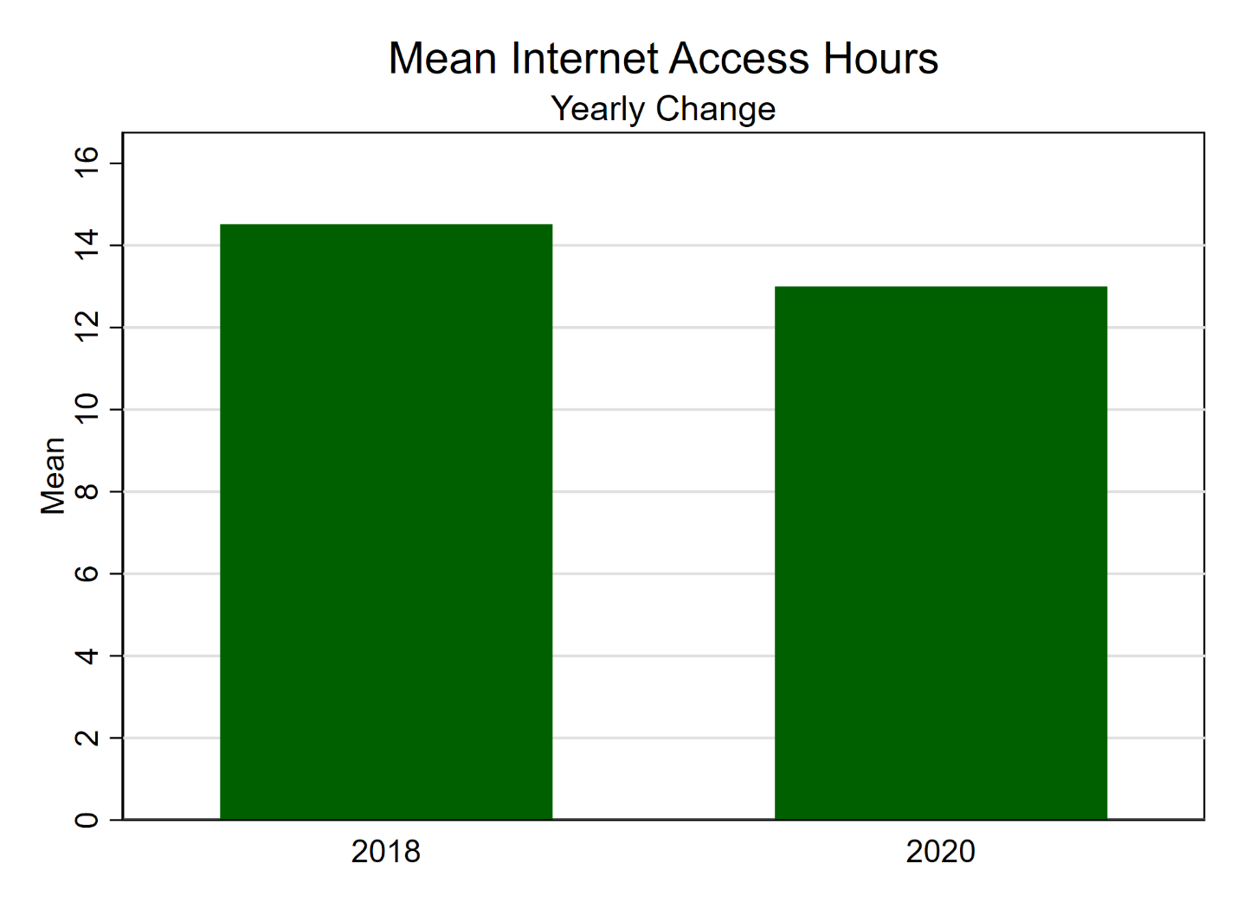

### ***Social Contact***

The General Social Survey contains four different measures of social interaction: *socbar, socfrend, socommun,* and *socrel*, respectively asking how often an individual spends his social evening at the bar, with friends, with neighbors or with relatives. A considerable number of papers (Mewes et al., 2021; Zhang & Xiang, 2019; Bianchi & Vohs, 2016) have adopted Glanville’s (2013) transformation of the four variables, which were previously coded in a 1 to 7 scale (going from “Almost Daily” to “Never”). This consists in turning a combination of the four into a numeric indication of days per year, with “Almost Daily” being assigned 300, “Once a year” 1, “Never” 0, and “Several” being 4 (thus “Several Times a Week is 208 or 4x52, “Several Times a Month” is 48 or 4x12, and “Several Times a Year is 4 or 4x1). In this paper, the variables were simply coded from 1 through 4, going from “Daily” to “Yearly”. The presence of all variables in both wave ballots allows for constant tracking of their effect, which is expected to be positive on all the dependent variables. People at different extremes of this factor variable will be more likely to experience the negative effects of loneliness and online interactions on our three dependent variables (Kim, 2017; Pittman, 2018), while the positive effect among people within the middle of the distribution has been shown to be typically positive and still significant (Chopik, 2016).

*Table 4: Social Interaction and Online Interaction Terms by Year (cont.)*

|  |  |  |  |  |  |  |
| --- | --- | --- | --- | --- | --- | --- |
|  | *year* | | | | |  |
|  | *2018* | | *2020* | | *Total* | *Sample size* |
|  | % | SE | % | SE | % |  |
| *How Frequently Use Online Communication* |  |  |  |  |  |  |
| Low or Mid-Level Online Presence | 41.4 | (1.903) | 58.6 | (1.903) | 100.0 | 614 |
| High Online Presence | 58.4 | (1.887) | 41.6 | (1.887) | 100.0 | 497 |
| Total | 49.6 | (1.113) | 50.4 | (1.113) | 100.0 | 1,111 |
| *How Frequently Spend Evening at Bar* |  |  |  |  |  |  |
| Often | 69.8 | (5.514) | 30.2 | (5.514) | 100.0 | 66 |
| Sometimes | 57.6 | (2.922) | 42.4 | (2.922) | 100.0 | 253 |
| Rarely | 50.7 | (1.934) | 49.3 | (1.934) | 100.0 | 414 |
| Never | 51.0 | (1.218) | 49.0 | (1.218) | 100.0 | 610 |
| Total | 53.1 | (0.449) | 46.9 | (0.449) | 100.0 | 1,343 |
| *How Frequently Spend Evening with Friends* |  |  |  |  |  |  |
| Often | 62.8 | (3.335) | 37.2 | (3.335) | 100.0 | 205 |
| Sometimes | 57.6 | (1.688) | 42.4 | (1.688) | 100.0 | 581 |
| Rarely | 47.4 | (2.234) | 52.6 | (2.234) | 100.0 | 403 |
| Never | 37.2 | (3.015) | 62.8 | (3.015) | 100.0 | 153 |
| Total | 53.3 | (0.471) | 46.7 | (0.471) | 100.0 | 1,342 |
| *How Frequently Spend Evening with Neighbors* |  |  |  |  |  |  |
| Often | 57.1 | (3.662) | 42.9 | (3.662) | 100.0 | 226 |
| Sometimes | 54.8 | (2.342) | 45.2 | (2.342) | 100.0 | 352 |
| Rarely | 53.3 | (2.312) | 46.7 | (2.312) | 100.0 | 316 |
| Never | 50.1 | (2.150) | 49.9 | (2.150) | 100.0 | 447 |
| Total | 53.2 | (0.473) | 46.8 | (0.473) | 100.0 | 1,341 |
| *How Frequently Spend Evening with Relatives* |  |  |  |  |  |  |
| Often | 56.3 | (1.885) | 43.7 | (1.885) | 100.0 | 456 |
| Sometimes | 53.9 | (1.899) | 46.1 | (1.899) | 100.0 | 489 |
| Rarely | 49.5 | (2.402) | 50.5 | (2.402) | 100.0 | 330 |
| Never | 44.1 | (5.154) | 55.9 | (5.154) | 100.0 | 67 |
| Total | 53.3 | (0.471) | 46.7 | (0.471) | 100.0 | 1,342 |
| Source: 03_GSS_ANES_merge | | | | | | |

### ***Political Participation***

Differing from previous research, the behavioral aspect of social trust is placed upon a person’s willingness to participate in political and community activities. This is not the same as spending time with friends and acquaintances, but rather shows a level of connectedness with the individual’s surroundings that is strong enough to warrant collaboration and participation. Questions that tracked a person’s political participation in 2018 were included in the GSS *partpart* and *partvol* variables (“In the past 12 months, how often, if at all, have you taken part in the activities? Of political parties, political groups or political associations?” and “In the past 12 months, how often, if at all, have you taken part in the activities? Of charitable or religious organizations that do voluntary work?”). Each of these are coded on a 5-point scale, going from “Once a Week or More” to “Never”, which were then collapsed to a binary showing if a person has participated to political activities (1) or not (0). In 2020, the ANES annex contained 9 different questions tracking political participation, not including direct contact with governmental institutions. These asked for an individual’s participation in political arguments, marches, religious organizations, money donations, online discussions, community problem-solving, school management, and volunteering, with each being coded as 1 “Have done this in the past 12 months” and 2 “Have not done this in the past 12 months”.

In a similar fashion as the social cohesion dependent variable, two grouped variables (one tracking online political participation and one offline political participation) were created indicating if a person had participated to at least three of the following activities (1): online political meetings, rallies, speeches and fundraisers, posting comments online about political issues, signed an internet petition, political arguments, and giving money to a social organization for online participation; the latter two added to attending physical political meetings, rallies, speeches, and dinners, working with others with issues facing the community, and attending meetings about community issues for offline participation.

Finally, to account for volunteering activities, the 2018 *partvol* variablewas associated with a grouped binary indicating if respondents had done any volunteering work or given money to a religious organization. Political participation is expected to have a positive effect on all three dependent variables, but its effect will be reduced by the higher levels of online communication (Moy et al., 2005), but only at either very high or very low levels of social contact.

*Table 5: Social Participation by Year*

|  |  |  |  |  |  |  |
| --- | --- | --- | --- | --- | --- | --- |
|  | *year* | | | | |  |
|  | *2018* | | *2020* | | *Total* | *Sample size* |
|  | % | SE | % | SE | % |  |
| *Offline Political Participation (12 Months)* |  |  |  |  |  |  |
| Not Participated | 44.4 | (1.417) | 55.6 | (1.417) | 100.0 | 929 |
| Participated | 62.6 | (3.236) | 37.4 | (3.236) | 100.0 | 214 |
| Total | 47.8 | (1.091) | 52.2 | (1.091) | 100.0 | 1,143 |
| *Online Political Participation (12 Months)* |  |  |  |  |  |  |
| Not Participated | 48.6 | (1.473) | 51.4 | (1.473) | 100.0 | 845 |
| Participated | 45.7 | (2.810) | 54.3 | (2.810) | 100.0 | 298 |
| Total | 47.8 | (1.091) | 52.2 | (1.091) | 100.0 | 1,143 |
| *Volunteering Participation (12 Months)* |  |  |  |  |  |  |
| Not Participated | 41.9 | (1.831) | 58.1 | (1.831) | 100.0 | 508 |
| Participated | 52.9 | (1.554) | 47.1 | (1.554) | 100.0 | 636 |
| Total | 48.1 | (1.097) | 51.9 | (1.097) | 100.0 | 1,144 |
| *Frequency of Religious Attendance* |  |  |  |  |  |  |
| Never | 100.0 | (0.000) | 0.0 | (0.000) | 100.0 | 306 |
| Rarely | 33.1 | (2.047) | 66.9 | (2.047) | 100.0 | 603 |
| Sometimes | 52.3 | (1.989) | 47.7 | (1.989) | 100.0 | 526 |
| Often | 51.8 | (1.544) | 48.2 | (1.544) | 100.0 | 525 |
| Total | 54.6 | (0.475) | 45.4 | (0.475) | 100.0 | 1,960 |
| Source: 03_GSS_ANES_merge | | | | | | |

## **Controls**

While the FE model does deal with time-invariant variable effects, certain time-variant aspects of a person’s daily life can indirectly affect the role that online communication has in health (age, occupational technology use), happiness (income, marriage happiness), and social cohesion (religious attendance, cohabitation status).

### ***Marriage Happiness and Cohabitation Status***

Marriage happiness has been shown to shield people from stressors of mental health. To this degree, DeMaris (2018) finds this relationship to be significant, also providing a length of other studies backing his results, and if we further consider the elevated importance of a partner’s intimate relationship within the perception of social connectedness (Prohaska et al., 2020), marriage can severely skew our estimation. In addition, we place it as a time variant control due to the consistent high number of divorces and the declining number of marriages within the U.S. (National Vital Statistics System, 2022), with *marital* being a consistent variable in presence across waves. Still, considering that the physical presence of the partner itself is further important to the overall effect of the intimate connection, *marcohab*, which tracks if a person is both married *and* living with their spouse, was used as an alternative to *marital*.

### ***Income***

A person’s income can come to affect daily internet usage, as people in the poorer tracts might find it more difficult to sustain a good internet connection (Powell et al., 2010). Apart from this basic distinction, analysis sustained on GSS data has already shown the relationship between lower happiness and less fortunate socio-economic groups; Hout (2016) and Hastings (2018) had also previously found that there is some degree of relationship between trust and income inequality within states. Further, it is common for other papers analyzing panel data to take the log transformation of income as a measure of control (Carl & Billari, 2014; Zhang & Xiang, 2019), and to use family income rather than respondent income as it tracks occupational earnings rather than total earnings. Mewes, Fairbrother, Giordano, Wu, and Wilkes (2021) further divided inflation adjusted income (*realinc*) with the square root of the number of household members, to account for individual disposable income. However, considering that *hompop* (tracking number of persons in the household) does not have a corresponding 2020 counterpart, we would have to assume that household size did not change between waves, thus warranting the use of the simple log transformation.

### ***Religious Attendance***

Attendance at religious events allows people to feel more connected to one another and gives them additional reasons to get together and avoid isolation (Whitehead & Stroope, 2015). Secular analysis by Hastings (2016) further proves this point by indicating that, while quality of friendship could not be verified, both spiritual and non-spiritual persons benefit by engaging in religious activities. Other papers further point at the role of religious participation on an increased sense of wellbeing, connectedness and social participation (Dunbar, 2021; Lewis et al., 2013), although the relationship with life satisfaction requires a stronger spiritual connection with the group (Lim & Putnam, 2010). We assume, nevertheless, that religiosity is time-invariant within our sample selection, and we only use *attend* as a tracker of religious service attendance (“How often do you attend religious services?).

### ***Technology Use***

Inclusion of technology use in our model has to be twofold. Firstly, we would need to take into account the change in actual hours spent on the internet since the pandemic has caused an exogenous increase in online interactions. Verily, as discussed before, private investigations in the change of internet use patterns revealed a consistent increase throughout 2020 and 2021 (McClain, Vogels, Perrin, Sechopoulos, & Rainie, 2021). To this point, a simple inclusion of *wwwhr* (“Not counting e-mail, about how many minutes or hours per week do you use the Web? (Include time you spend visiting regular web sites and time spent using interactive Internet services like chat rooms, Usenet groups, discussion forums, bulletin boards, and the like.)”), would suffice to control for this change. However, we should also take into account the role that the digital world has in the individual’s life, as people whose work directly involves heavy internet use might skew simple tracking of hours spent on the web. As such, *occ10,* which uses the census’ occupational coding,will be adapted into an *occSTEM* dummy placing individuals whose job is labelled as STEM at 1 and others at 0[4].

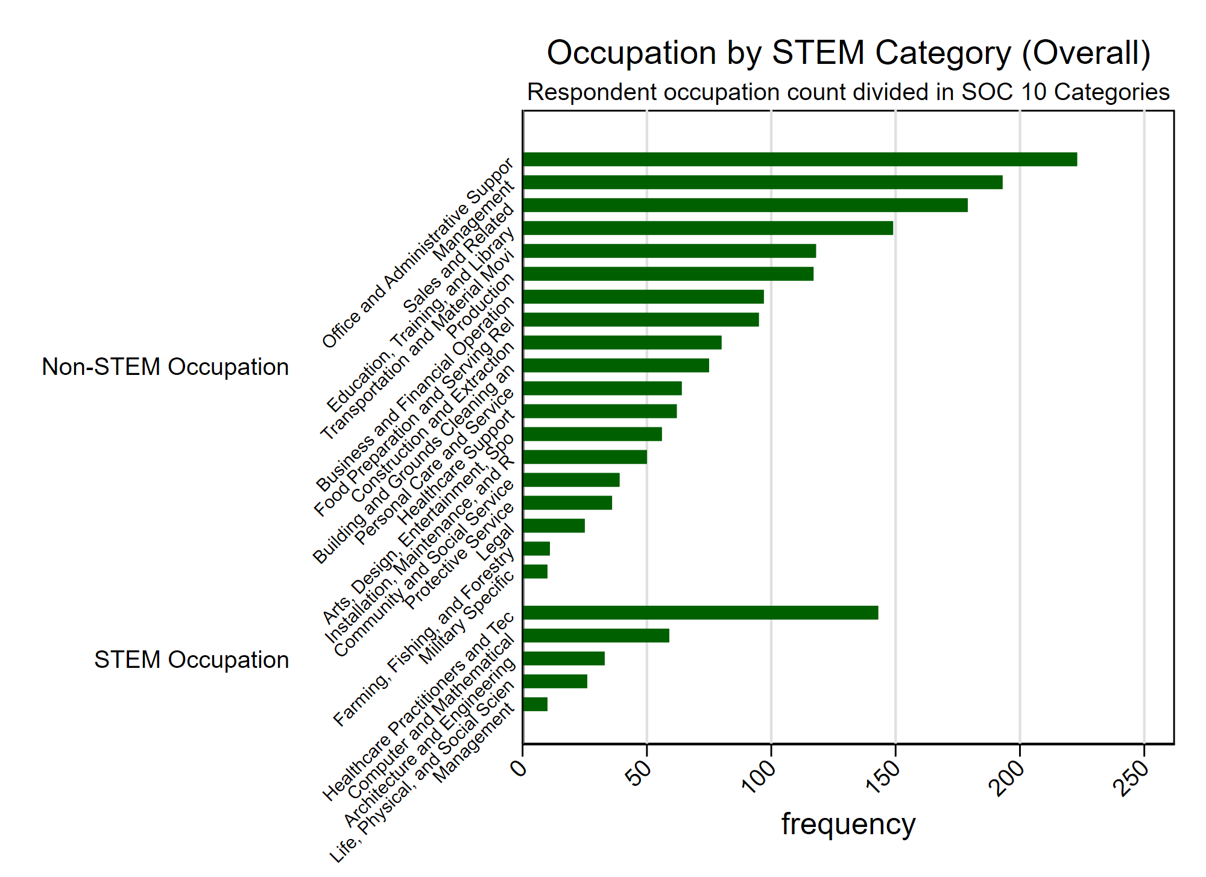

### ***Age***

While it is true that a person’s age may affect their rate of technological use, the role of age in our analysis connects more with its mediation between technology use and loneliness. The GlobalWebIndex report (Mander et al., 2020) indicates that baby boomers and older generations have begun to diversify their digital life and increase their non-face to face connectiveness with considerable reductions in measures of loneliness (Luchetti et al., 2020). Within the GSS, age is a continuous variable making it necessary to create a factored dummy with a “65 and over” category to account for the generational effect.

## **Addressing Missingness**

Panel data is unfortunately prone to missingness due to attrition or methodological changes across panel years. In fact, even in the 2016-2020 panel, though wording remains relatively identical across included variables, certain questions are either omitted or changed from the 2016 and 2018 waves to the 2020 wave. In addition, non-response negatively affects the explanatory power of certain variables, and imputation is necessary to reestablish the usefulness of the data. The 2016-2020 panel was selected for its relative stability in questionnaire variation, and a previous analysis by Smith and Son (2010) on the patterns of missingness within the 2006-2008 survey panel indicates that more complex questions tend to attract higher percentages of missingness, confirmed by the completeness of demographic variables such as race (99.51%) and sex (99.31%) in our own dataset.

**References**

American National Election Studies. (2022). *ANES-GSS 2020 Joint Study*[dataset and documentation]. April 8, 2022 version. [www.electionstudies.org](http://www.electionstudies.org/)

Baetschmann, G., Ballantyne, A., Staub, K. E., & Winkelmann, R. (2020). feologit: A new command for fitting fixed-effects ordered logit models. *The Stata Journal*, *20*(2), 253-275.

Baetschmann, G., Staub, K. E., & Winkelmann, R. (2015). Consistent estimation of the fixed effects ordered logit model. *Journal of the Royal Statistical Society: Series A (Statistics in Society)*, *178*(3), 685-703.

Bianchi, E. C., & Vohs, K. D. (2016). Social class and social worlds: Income predicts the frequency and nature of social contact. *Social Psychological and Personality Science*, *7*(5), 479-486.

Carl, N., & Billari, F. C. (2014). Generalized trust and intelligence in the United States. *PloS one*, *9*(3), e91786.

Cham, H., Reshetnyak, E., Rosenfeld, B., & Breitbart, W. (2017). Full information maximum likelihood estimation for latent variable interactions with incomplete indicators. *Multivariate behavioral research*, *52*(1), 12-30.

Chopik, W. J. (2016). The benefits of social technology use among older adults are mediated by reduced loneliness. *Cyberpsychology, Behavior, and Social Networking*, *19*(9), 551-556.

Davern, M., Bautista, R., Freese, J., Morgan, S. L., & Smith, T. W. (Release 1a, 2022, April). General Social Survey Panel Data (2016-2020). <https://doi.org/10.17605/OSF.IO/HACZV>

Dunbar, R. I. (2021). Religiosity and religious attendance as factors in wellbeing and social engagement. *Religion, Brain & Behavior*, *11*(1), 17-26.

Enders, C. K., & Bandalos, D. L. (2001). The relative performance of full information maximum likelihood estimation for missing data in structural equation models. *Structural equation modeling*, *8*(3), 430-457.

Fawcett, B., & Karastoyanova, K. (2022). Older people, loneliness, social isolation and technological mitigations: utilising experiences of the Covid-19 pandemic as we move forward. *The British Journal of Social Work*.

Filiposka, S., Gajduk, A., Dimitrova, T., & Kocarev, L. (2017). Bridging online and offline social networks: Multiplex analysis. *Physica A: Statistical Mechanics and its Applications*, *471*, 825-836.

Glanville, J. L., Andersson, M. A., & Paxton, P. (2013). Do social connections create trust? An examination using new longitudinal data. *Social Forces*, *92*(2), 545-562.

Hastings, O. P. (2018). Less equal, less trusting? Longitudinal and cross-sectional effects of income inequality on trust in US States, 1973–2012. *Social Science Research*, *74*, 77-95.

Holt-Lunstad, J., & Steptoe, A. (2022). Social isolation: An underappreciated determinant of physical health. *Current Opinion in Psychology*, *43*, 232-237.

Hout, M. (2016). Money and morale: Growing inequality affects how Americans view themselves and others. *The ANNALS of the American Academy of Political and Social Science*, *663*(1), 204-228.

Howell, D. (July 14, 2022). The American National Election Studies (ANES) awarded $14 million to study 2024 elections. *ANES* [Press Release]. Accessed on November 17, 2022. <https://electionstudies.org/anes-2024-award/>

Kim, J. H. (2017). Smartphone-mediated communication vs. face-to-face interaction: Two routes to social support and problematic use of smartphone. *Computers in Human Behavior*, *67*, 282-291.

Larsen, R. (2011). Missing data imputation versus full information maximum likelihood with second-level dependencies. *Structural Equation Modeling: A Multidisciplinary Journal*, *18*(4), 649-662.

Lee, J., & Lee, H. (2010). The computer-mediated communication network: Exploring the linkage between the online community and social capital. *new media & society*, *12*(5), 711-727.

Lewis, V. A., MacGregor, C. A., & Putnam, R. D. (2013). Religion, networks, and neighborliness: The impact of religious social networks on civic engagement. *Social science research*, *42*(2), 331-346.

Lim, C., & Putnam, R. D. (2010). Religion, social networks, and life satisfaction. *American sociological review*, *75*(6), 914-933.

Mander J., Buckle C., & Moran S. (2020). Social: GlobalWebIndex’s flagship report on the latest trends in social media. *GlobalWebIndex*. Retrieved from <https://amai.org/covid19/descargas/SocialGlobalWebIndex.pdf>

McClain, C., Vogels, E. A., Perrin, A., Sechopoulos, S., & Rainie, L. (2021). The Internet and the pandemic. *Pew Research Center*. Retrieved from <https://www.pewresearch.org/internet/2021/09/01/the-internet-and-the-pandemic/>

Mewes, J., Fairbrother, M., Giordano, G. N., Wu, C., & Wilkes, R. (2021). Experiences matter: A longitudinal study of individual-level sources of declining social trust in the United States. *Social Science Research*, *95*, 102537.

Moy, P., Manosevitch, E., Stamm, K., & Dunsmore, K. (2005). Linking dimensions of Internet use and civic engagement. *Journalism & Mass Communication Quarterly*, *82*(3), 571-586.

National Vital Statistics System. (February 7, 2022). National marriage and divorce rate trends for 2000 – 2020. *National Center for Health Statistics (CDC)*. Accessed on November 18, 2022. <https://www.cdc.gov/nchs/data/dvs/national-marriage-divorce-rates-00-20.pdf>

Park, H. M. (2011). Practical guides to panel data modeling: a step-by-step analysis using stata. *Public Management and Policy Analysis Program, Graduate School of International Relations, International University of Japan*, *12*, 1-52.

Park, H. M. (2015). Linear regression models for panel data using SAS, Stata, LIMDEP, and SPSS.

Paxton, P. (1999). Is social capital declining in the United States? A multiple indicator assessment. *American Journal of sociology*, *105*(1), 88-127.

Pittman, M. (2018). Happiness, loneliness, and social media: perceived intimacy mediates the emotional benefits of platform use. *The Journal of Social Media in Society*, *7*(2), 164-176.

Powell, A., Bryne, A., & Dailey, D. (2010). The essential Internet: Digital exclusion in low‐income American communities. *Policy & Internet*, *2*(2), 161-192.

Prohaska, T., Burholt, V., Burns, A., Golden, J., Hawkley, L., Lawlor, B., ... & Fried, L. (2020). Consensus statement: loneliness in older adults, the 21st century social determinant of health?. *BMJ open*, *10*(8), e034967.

Riedl, M., & Geishecker, I. (2014). Keep it simple: estimation strategies for ordered response models with fixed effects. *Journal of Applied Statistics*, *41*(11), 2358-2374.

Smith, T. W., & Son, J. (2010). *An analysis of panel attrition and panel change on the 2006-2008 General Social Survey Panel*. NORC/University of Chicago.

Steafnone, M. A., Huang, Y. C., & Lackaff, D. (2011, January). Negotiating social belonging: Online, offline, and in-between. In *2011 44th Hawaii International Conference on System Sciences* (pp. 1-10). IEEE.

Vacchiano, M., & Bolano, D. (2021). Online and offline leisure, relatedness and psychological distress: A study of young people in Switzerland. *Leisure Studies*, *40*(3), 338-351.

Vaisey, S., & Miles, A. (2017). What you can—and can’t—do with three-wave panel data. *Sociological Methods & Research*, *46*(1), 44-67.

Whitehead, A. L., & Stroope, S. (2015). Small groups, contexts, and civic engagement: A multilevel analysis of United States Congregational Life Survey data. *Social Science Research*, *52*, 659-670.

Williams, R., Allison, P. D., & Moral-Benito, E. (2018). Linear dynamic panel-data estimation using maximum likelihood and structural equation modeling. *The Stata Journal*, *18*(2), 293-326.

Yang, Y., & Land, K. C. (2008). Age–period–cohort analysis of repeated cross-section surveys: fixed or random effects?. *Sociological methods & research*, *36*(3), 297-326.

Zhang, S., & Xiang, W. (2019). Income gradient in health-related quality of life—The role of social networking time. *International journal for equity in health*, *18*(1), 1-10.

1. Information obtained from the GSS website: <https://gss.norc.org/About-The-GSS>
2. Panstat tracks whether a respondent was selected and reinterviewed (1 = Selected, Eligible, and Re-Interviewed, 2 = Not Selected, 3 = Selected, but not re-interviewed, 4 = Selected, but not eligible and not re-interviewed because R was deceased, 5 = Selected, but not eligible and not re-interviewed because R was permanently incapacitated, outside the U.S., or otherwise out of scope)
3. Paxton’s research also looked into elements of trust in institutions and of social connections, which relates back to the use of social participation as an independent variable (Figure 1 and Figure 2)
4. STEM classification was taken directly from the U.S. Bureau of Labor Statistics, and the *occ10* was first divided into the 23 original SOC 10 categories before being turned into a binary.